

**Project Report**

**On**

**Airline Ticket Reservation System**

(CSD 2206-5 DATABASE DESIGN AND SQL)

**Submitted to: Submitted by:**

Ms. Rachida Amjoun Lovepreet Kaur (C0763499)

Minh Phuong Ly (C0757038)

Aneesha Ann Aloysious (C0769743)

Honey Mathew (C0765178)

**CONTENTS**

INTRODUCTION 3

IMPLEMENTATION OF PHYSICAL MODEL 4

Database Creation: 4

BUSINESS RULES: 15

TOOLS USED 15

Applying Business Rules And Adding Constraints: 15

Records insertion 18

Constraints Testing 28

# INTRODUCTION

Airline Ticket Reservation System is a database project that facilitate the reservation of the online air tickets through an effective and yet simple GUI for a normal passenger intending to travel in airways. The project is basically targeted all those people who would like to travel through air. Apart from reserving tickets, through this system a passenger can compare fares ‘from’ various cities ‘to’ various cities.

# IMPLEMENTATION OF PHYSICAL MODEL

## Database Creation:

1. Create database with name AIRWAY_BOOKING.

|  |
| --- |
| CREATE DATABASE AIRWAY_BOOKING; |

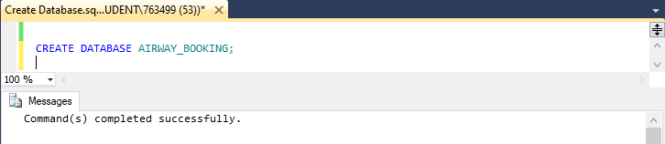

1. Create table AIRPORT.

|  |
| --- |
| USE AIRWAY_BOOKING;  CREATE TABLE AIRPORT(  airport_id CHAR(3) NOT NULL,  name varchar(50) NOT NULL,  country varchar(20) NOT NULL,  city varchar(20) NOT NULL,  description varchar(10)  CONSTRAINT AIRPORT_airport_id_pk PRIMARY KEY (airport_id)  ); |

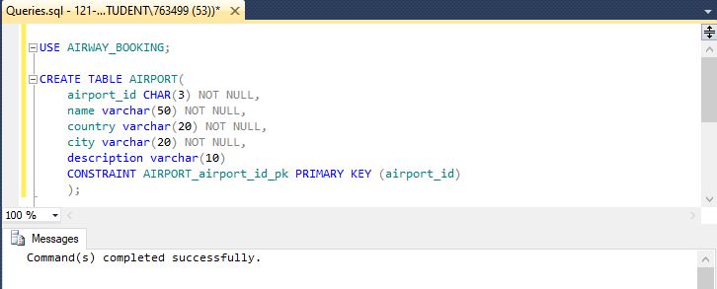

1. Create table TERMINAL.

|  |
| --- |
| USE AIRWAY_BOOKING;  CREATE TABLE TERMINAL(  terminal_id smallint NOT NULL,  airport_id char(3) NOT NULL,  terminal_name char(3) NOT NULL,  description varchar(10),  CONSTRAINT TERMINAL_terminal_id_pk PRIMARY KEY (terminal_id),  CONSTRAINT TERMINAL_airport_id_fk FOREIGN KEY (airport_id)  REFERENCES AIRPORT(airport_id)  ); |

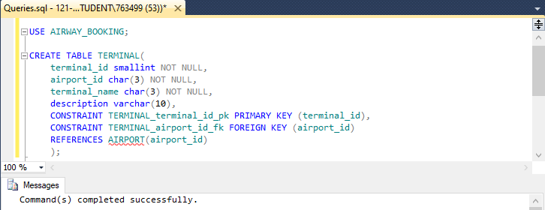

1. Create table GATE.

|  |
| --- |
| USE AIRWAY_BOOKING;  CREATE TABLE GATE(  gate_id smallint NOT NULL,  terminal_id smallint NOT NULL,  gate_name varchar(10) NOT NULL,  CONSTRAINT GATE_gate_id_pk PRIMARY KEY (gate_id),  CONSTRAINT GATE_terminal_id_fk FOREIGN KEY (terminal_id)  REFERENCES TERMINAL(terminal_id)  ); |

|  |
| --- |
|  |

1. Create table AIRLINE.

|  |
| --- |
| USE AIRWAY_BOOKING;  CREATE TABLE AIRLINE(  airline_id CHAR(2) NOT NULL,  airline_name varchar(50) NOT NULL,  description varchar(50),  CONSTRAINT AIRLINE_airline_id_pk PRIMARY KEY (airline_id)  ); |

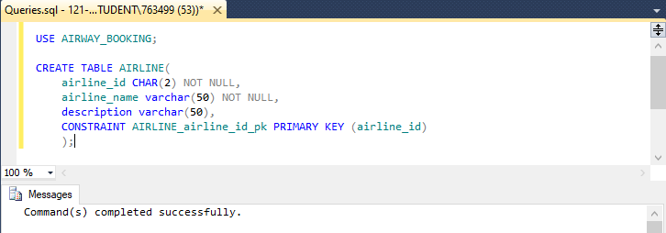

1. Create table AIRCRAFT.

|  |
| --- |
| USE AIRWAY_BOOKING;  CREATE TABLE AIRCRAFT(  aircraft_id varchar(10) NOT NULL,  airline_id char(2) NOT NULL,  aircraft_name varchar(50) NOT NULL,  number_eco_seat smallint NOT NULL,  number_bus_seat smallint NOT NULL,  description varchar(50),  CONSTRAINT AIRCRAFT_aircraft_id_pk PRIMARY KEY (aircraft_id),  CONSTRAINT AIRCREAFT_airline_id_fk FOREIGN KEY (airline_id)  REFERENCES AIRLINE(airline_id)  ); |

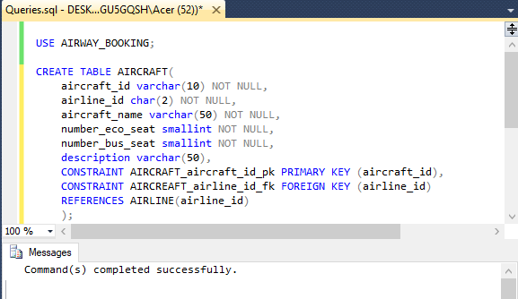

1. Create table ROUTE.

|  |
| --- |
| USE AIRWAY_BOOKING;  CREATE TABLE ROUTE(  route_id varchar(10) NOT NULL,  source_airport_id char(3) NOT NULL,  destination_airport_id char(3) NOT NULL,  CONSTRAINT ROUTE_route_id_pk PRIMARY KEY (route_id),  CONSTRAINT ROUTE_source_airport_id_fk FOREIGN KEY (source_airport_id)  REFERENCES AIRPORT(airport_id),  CONSTRAINT ROUTE_destination_airport_id_fk FOREIGN KEY(destination_airport_id)  REFERENCES AIRPORT(airport_id)  ); |

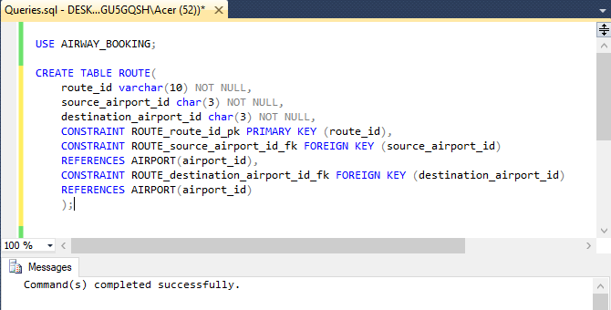

1. Create table ROUTE_GROUP.

|  |
| --- |
| USE AIRWAY_BOOKING;  CREATE TABLE ROUTE_GROUP(  route_group_id varchar(10) NOT NULL,  source_airport_id char(3) NOT NULL,  destination_airport_id char(3) NOT NULL,  CONSTRAINT ROUTE_GROUP_route_group_id_pk PRIMARY KEY (route_group_id),  CONSTRAINT ROUTE_GROUP_source_airport_id_fk FOREIGN KEY (source_airport_id)  REFERENCES AIRPORT(airport_id),  CONSTRAINT ROUTE_GROUP_destination_airport_id_fk FOREIGN KEY (destination_airport_id)  REFERENCES AIRPORT(airport_id)  ); |

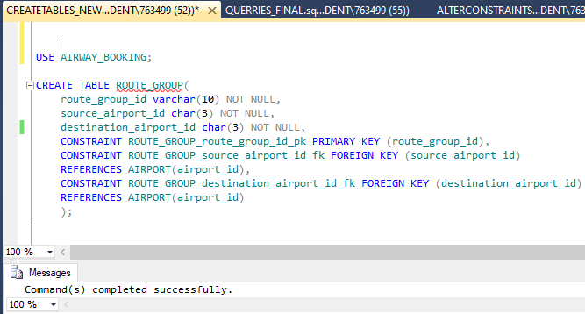

1. Create table ROUTE_GROUP_DETAIL.

|  |
| --- |
| USE AIRWAY_BOOKING;  CREATE TABLE ROUTE_GROUP_DETAIL(  route_id varchar(10) NOT NULL,  route_group_id varchar(10) NOT NULL,  CONSTRAINT ROUTE_GROUP_DETAIL_route_group_id_pk PRIMARY KEY (route_group_id,route_id),  CONSTRAINT ROUTE_GROUP_DETAIL_route_group_id_fk FOREIGN KEY (route_group_id)  REFERENCES ROUTE_GROUP(route_group_id),  CONSTRAINT ROUTE_GROUP_DETAIL_route_id_fk FOREIGN KEY (route_id)  REFERENCES ROUTE(route_id)  ); |

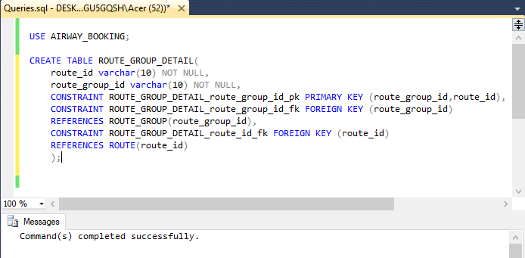

1. Create table FLIGHT.

|  |
| --- |
| USE AIRWAY_BOOKING;  CREATE TABLE FLIGHT(  flight_id varchar(10) NOT NULL,  aircraft_id varchar(10) NOT NULL,  route_id varchar(10) NOT NULL,  gate_id smallint NOT NULL,  depart_date datetime NOT NULL,  arrive_date datetime NOT NULL,  eco_class_price float(15) NOT NULL,  bus_class_price float(15) NOT NULL,  status varchar(15) NOT NULL,  CONSTRAINT FLIGHT_flight_id_pk PRIMARY KEY (flight_id),  CONSTRAINT FLIGHT_aircraft_id_fk FOREIGN KEY (aircraft_id)  REFERENCES AIRCRAFT(aircraft_id),  CONSTRAINT FLIGHT_gate_id_fk FOREIGN KEY (gate_id)  REFERENCES GATE(gate_id),  CONSTRAINT FLIGHT_route_id_fk FOREIGN KEY (route_id)  REFERENCES ROUTE(route_id)  ); |

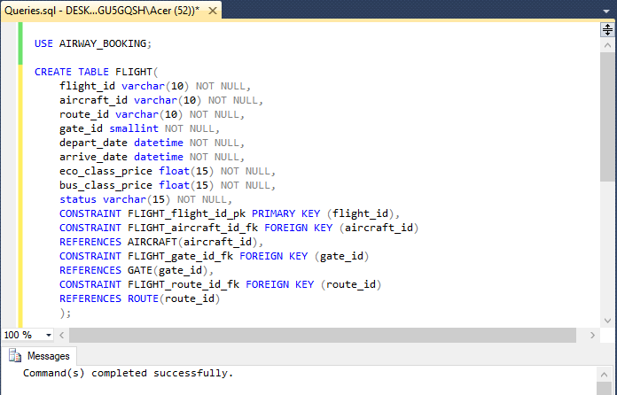

1. Create table PASSENGER_INFO.

|  |
| --- |
| USE AIRWAY_BOOKING;  CREATE TABLE PASSENGER_INFO(  passport_number varchar(20) NOT NULL,  name varchar(30) NOT NULL,  phone char(10) NOT NULL,  date_of_birth date NOT NULL,  address varchar(50) NOT NULL,  email varchar(30) NOT NULL,  CONSTRAINT PASSENGER_INFO_passport_number_pk PRIMARY KEY (passport_number),  ); |

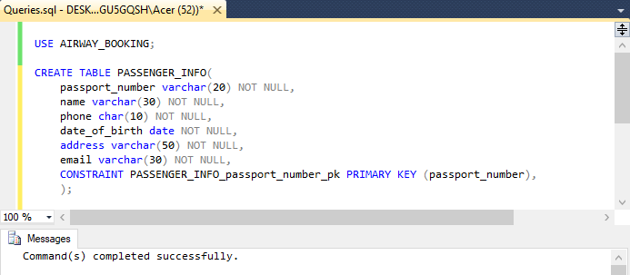

1. Create table PASSENGER.

|  |
| --- |
| USE AIRWAY_BOOKING;  CREATE TABLE PASSENGER(  passenger_id varchar(20) NOT NULL,  passport_number varchar(20) NOT NULL,  CONSTRAINT PASSENGER_passenger_id_pk PRIMARY KEY (passenger_id),  CONSTRAINT PASSENGER_passport_number_fk FOREIGN KEY (passport_number)  REFERENCES PASSENGER_INFO(passport_number)  ); |

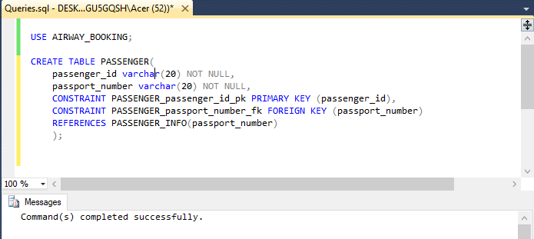

1. Create table PAYMENT_ACCOUNT.

|  |
| --- |
| USE AIRWAY_BOOKING;  CREATE TABLE PAYMENT_ACCOUNT(  card_id varchar(20) NOT NULL,  name varchar(30) NOT NULL DEFAULT 'NONE',  password smallint NOT NULL,  expire_date date NOT NULL,  CONSTRAINT PAYMENT_ACCOUNT_card_id_pk PRIMARY KEY (card_id)  ); |

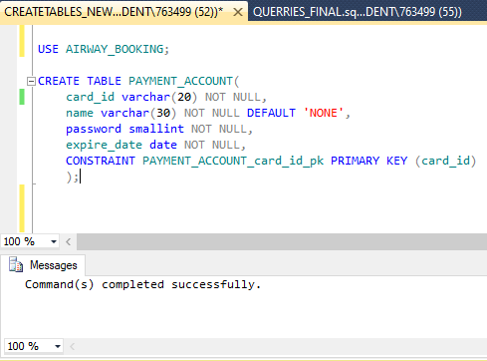

1. Create table BOOKING.

|  |
| --- |
| USE AIRWAY_BOOKING;  CREATE TABLE BOOKING(  booking_id varchar(20) NOT NULL,  card_id varchar(20) NOT NULL,  status varchar(10) NOT NULL,  discount float(4) NOT NULL DEFAULT 0.0,  issued_date datetime NOT NULL,  CONSTRAINT BOOKING_booking_id_pk PRIMARY KEY(booking_id),  CONSTRAINT BOOKING_card_id_fk FOREIGN KEY (card_id)  REFERENCES PAYMENT_ACCOUNT(card_id)  ); |

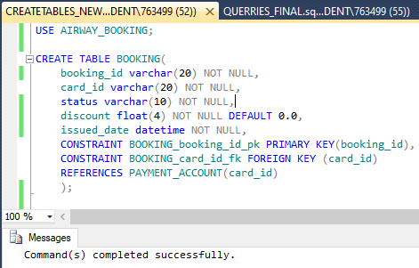

1. Create table TICKET.

|  |
| --- |
| USE AIRWAY_BOOKING;  CREATE TABLE TICKET(  ticket_id varchar(20) NOT NULL,  booking_id varchar(20) NOT NULL,  passenger_id varchar(20) NOT NULL,  flight_id varchar(10) NOT NULL,  class varchar(5) NOT NULL DEFAULT 'ECO',  seat_number varchar(3),  status varchar(10) NOT NULL,  issued_date datetime NOT NULL  CONSTRAINT TICKET_ticket_id_pk PRIMARY KEY(ticket_id),  CONSTRAINT TICKET_booking_id_fk FOREIGN KEY(booking_id)  REFERENCES BOOKING(booking_id),  CONSTRAINT TICKET_passenger_id_fk FOREIGN KEY(passenger_id)  REFERENCES PASSENGER(passenger_id),  CONSTRAINT TICKET_flight_id_fk FOREIGN KEY(flight_id)  REFERENCES FLIGHT(flight_id)  ); |

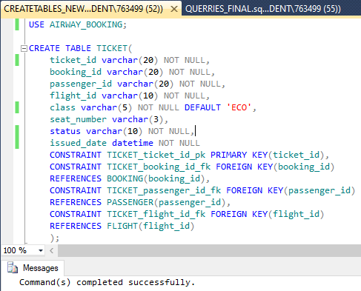

## BUSINESS RULES:

Every database is consisting of some rules and constraints to work properly and to avoid any incorrect data to get store. Business rules are a set of statements that specify what the user can or cannot do with the data inserted. Here are some constraints imposed on specific aspects of Airline Reservation System Database:

1. During payment, card expire date should be greater than current date
2. While booking a ticket, discount should not be less than 10.
3. In particular passenger information, every passenger must have unique email address.

## TOOLS USED

* SQL Server:

Every application requires a database system to store some data. SQL Server is a relational database management system (RDBMS) developed by Microsoft. It is primarily designed and developed to compete with MySQL and Oracle database. We have created our database using mysql queries.

* DRAW.IO:

It is an open source, browser-based application used for drawing diagrams by user end. We have used this tool in creating ER diagram of the project.

## Applying Business Rules And Adding Constraints:

1. All the Primary and Foreign Key Constraints have been set in the Table Creation session.
2. Setting constraint on card expiry date.

|  |
| --- |
| USE AIRWAY_BOOKING;  ALTER TABLE PAYMENT_ACCOUNT  ADD CONSTRAINT PAYMENT_ACCOUNT_expire_date_ck  CHECK (expire_date > GETDATE()); |

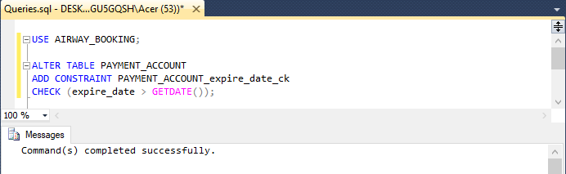

1. Setting constraint on booking discount.

|  |
| --- |
| USE AIRWAY_BOOKING;  ALTER TABLE BOOKING  ADD CONSTRAINT BOOKING_discount_ck  CHECK (discount<10); |

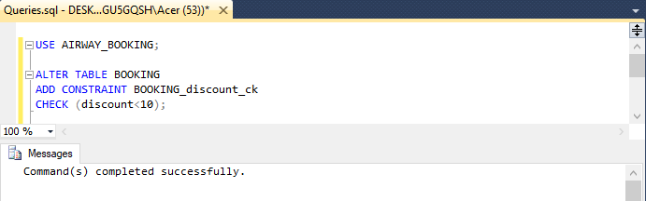

1. Setting constraint on passenger’s email address.

|  |
| --- |
| USE AIRWAY_BOOKING;  ALTER TABLE PASSENGER_INFO  ADD CONSTRAINT PASSENGER_INFO_email_uq  UNIQUE(email); |

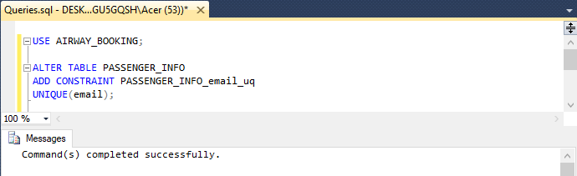

# Records insertion

1. Insert data to AIRPORT.

|  |
| --- |
| USE AIRWAY_BOOKING;  INSERT INTO AIRPORT(airport_id,name,country,city)  VALUES ('SGN','TAN SON NHAT INTERNATIONAL AIRPORT','VIETNAM','HO CHI MINH CITY'),  ('YYZ','LESTER B.PEARSON INTERNATIONAL AIRPORT','CANADA','TORONTO'),  ('DEL','INDIRA GANDHI INTERNATIONAL AIRPORT','INDIA','DELHI NCR'),  ('AMD','SARDAR VALLABHBHAI PATEL INTERNATIONAL AIRPORT','INDIA','AHMEDABAD'),  ('SFO','SAN FRANCISCO INTERNATIONAL AIRPORT','AMERICA','SAN FRANCISCO'),  ('JFK','JOHN F. KENNEDY INTERNATIONAL AIRPORT','AMERICA','NEW YORK'),  ('HAN','NOI BAI INTERNATIONAL AIRPORT','VIETNAM','HA NOI'),  ('YVR','VANCOUVER INTERNATIONAL AIRPORT','CANADA','VANCOUVER'),  ('TPE','TAIWAN TAOYUAN INTERNATIONAL AIRPORT','TAIWAN','TAOYUAN'),  ('HKG','HONG KONG INTERNATIONAL AIRPORT','HONG KONG','HONG KONG'); |

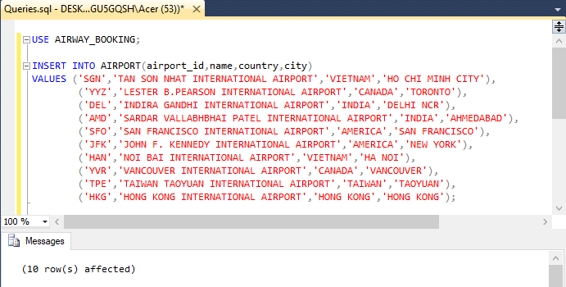

1. Insert data to TERMINAL.

|  |
| --- |
| USE AIRWAY_BOOKING;  INSERT INTO TERMINAL(terminal_id,airport_id,terminal_name)  VALUES (1,'SGN','A'), (2,'SGN','B'), (3,'YYZ','1'), (4,'YYZ','2'),(5,'DEL','A'),  (6,'DEL','B'),(7,'AMD','A'), (8,'AMD','B'), (9,'SFO','A'), (10,'SFO','B'),  (11,'JFK','A'), (12,'JFK','B'),(13,'HAN','1'), (14,'HAN','2'), (15,'YVR','A'),  (16,'YVR','B'), (17,'TPE','A'), (18,'TPE','B'),(19,'HKG','A'), (20,'HKG','B'); |

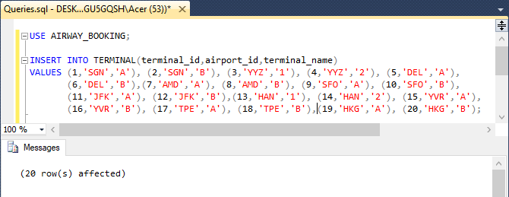

1. Insert data to GATE.

|  |
| --- |
| USE AIRWAY_BOOKING;  INSERT INTO GATE(gate_id, terminal_id,gate_name)  VALUES (1,1,'1'), (2,2,'5'),(3,3,'1'), (4,4,'5'),(5,5,'1'), (6,6,'5'),  (7,7,'1'), (8,8,'5'), (9,9,'1'), (10,10,'5'), (11,11,'1'), (12,12,'5'),  (13,13,'1'), (14,14,'5'), (15,15,'1'), (16,16,'5'), (17,17,'1'), (18,18,'5'),  (19,19,'1'), (20,20,'5'); |

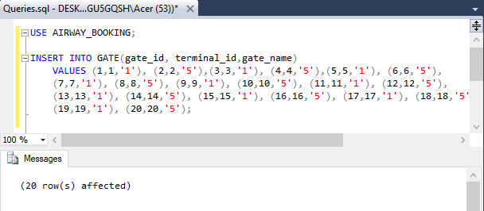

1. Insert data to AIRLINE.

|  |
| --- |
| USE AIRWAY_BOOKING;  INSERT INTO AIRLINE(airline_id,airline_name)  VALUES('RV','AIR CANADA ROUGE'),('CX','CATHAY PACIFIC'),('BR','EVA AIR'),  ('AC','AIR CANADA'),('S2','AIR SAHARA'),('VN','VIETNAM AIRLINES'),  ('2P','AIR PHILIPPINES'),('AA','AMERICAN AIRLINES'),('NQ','AIR JAPAN'),  ('SQ','SINGAPORE AIRLINES'); |

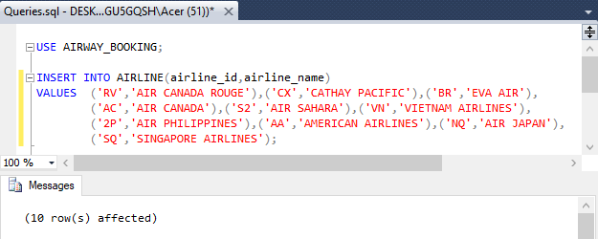

1. Insert data to AIRCRAFT.

|  |
| --- |
| USE AIRWAY_BOOKING;  INSERT INTO AIRCRAFT(aircraft_id,airline_id,aircraft_name,number_bus_seat,number_eco_seat)  VALUES('RV001','RV','BOEING 333',350,70),('RV002','RV','BOEING 453',360,50),  ('CX001','CX','BOEING 333',350,70),('CX002','CX','AIRBUS 330',300,100),  ('BR001','BR','BOEING 777',450,70),('BR002','BR','BOEING 350',450,70),  ('AC001','AC','BOEING 747',400,70),('AC002','AC','BOEING 300',350,70),  ('S2001','S2','BOEING 555',350,70),('S2002','S2','BOEING 373',355,70),  ('VN001','VN','BOEING 777',350,70),('VN002','VN','BOEING 555',250,40),  ('2P001','2P','AIRBUS 380',300,50),('2P002','2P','AIRBUS 999',450,100),  ('AA001','AA','BOEING 747',400,70),('AA002','AA','BOEING 303',200,30),  ('NQ001','NQ','BOEING 800',500,70),('NQ002','NQ','AIRBUS 400',450,70),  ('SQ001','SQ','BOEING 333',350,70),('SQ002','SQ','BOEING 333',350,70); |

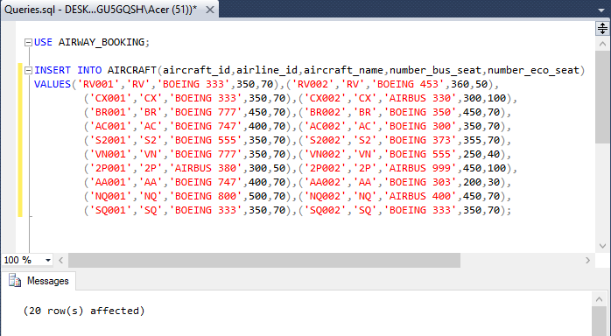

1. Insert data to ROUTE.

|  |
| --- |
| USE AIRWAY_BOOKING;  INSERT INTO ROUTE(route_id,source_airport_id,destination_airport_id)  VALUES ('0001','SGN','DEL'),('0002','SGN','TPE'),('0003','SGN','HKG'),  ('0004','SGN','HAN'),('0005','DEL','SGN'),('0006','TPE','SGN'),  ('0007','HKG','SGN'),('0008','HAN','SGN'),('0009','JFK','YYZ'),  ('0010','DEL','HKG'),('0011','DEL','TPE'),('0012','SFO','YVR'),  ('0013','AMD','DEL'),('0014','YYZ','JFK'),('0015','HKG','DEL'),  ('0016','TPE','DEL'),('0017','YVR','SFO'),('0018','DEL','AMD'),  ('0019','SGN','HAN'),('0020','TPE','YYZ'), ('0021','HKG','YYZ'),  ('0022','TPE','YVR'),('0023','TPE','JFK'),('0024','HAN','SGN'),  ('0025','YYZ','TPE'), ('0026','YYZ','HKG'),('0027','YVR','TPE'),  ('0028','JFK','TPE'); |

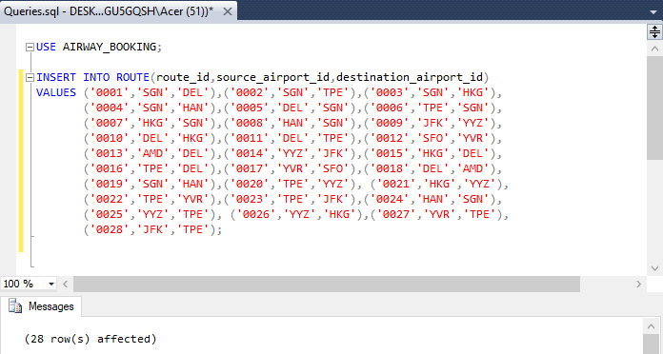

1. Insert data to ROUTE_GROUP.

|  |
| --- |
| USE AIRWAY_BOOKING;  INSERT INTO ROUTE_GROUP(route_group_id,source_airport_id,destination_airport_id)  VALUES ('0001','SGN','YYZ'),('0002','SGN','JFK'),('0003','SGN','YVR'),  ('0004','DEL','YYZ'),('0005','DEL','JFK'),('0006','YYZ','SGN'),  ('0007','JFK','SGN'),('0008','YVR','SGN'),('0009','YYZ','DEL'),  ('0010','JFK','DEL'),('0011','SGN','YYZ'),('0012','YYZ','SGN'); |

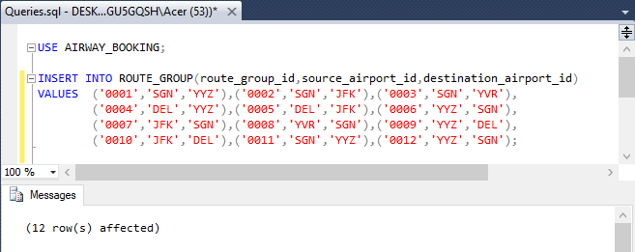

1. Insert data to ROUTE_GROUP_DETAIL.

|  |
| --- |
| USE AIRWAY_BOOKING;  INSERT INTO ROUTE_GROUP_DETAIL(route_id,route_group_id)  VALUES ('0002','0001'),('0020','0001'),('0002','0002'),('0023','0002'), ('0002','0003'),('0022','0003'),('0010','0004'),('0021','0004'),  ('0011','0005'),('0023','0005'),('0026','0006'),('0007','0006'),  ('0028','0007'),('0006','0007'),('0027','0008'),('0006','0008'),  ('0025','0009'),('0016','0009'),('0028','0010'),('0016','0010'),  ('0002','0011'),('0023','0011'),('0009','0011'),('0014','0012'),  ('0028','0012'),('0006','0012'); |

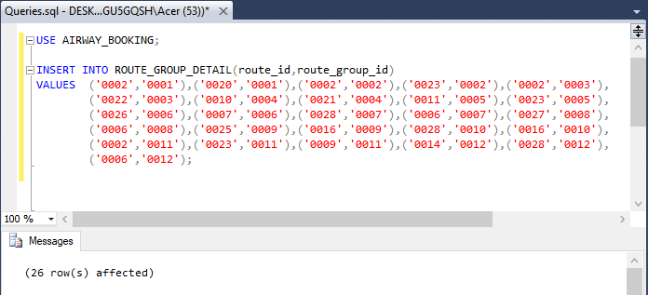

1. Insert data to FLIGHT.

|  |
| --- |
| USE AIRWAY_BOOKING;  INSERT INTO FLIGHT(flight_id,aircraft_id,route_id,gate_id,depart_date,arrive_date,eco_class_price,bus_class_price,status)  VALUES  ('2019110001','S2001','0001',1,'2019-11-25 08:40:00','2019-11-25 12:30:00', 500.5,750.99,'NONE'),  ('2019110002','BR002','0002',1,'2019-11-26 08:40:00','2019-11-26 12:40:00', 500.5,750.99,'NONE'),  ('2019110003','CX001','0003',1,'2019-11-27 08:40:00','2019-11-27 11:30:00', 500.5,750.99,'NONE'),  ('2019110004','VN001','0004',1,'2019-11-28 08:40:00','2019-11-28 12:30:00', 500.5,750.99,'NONE'),  ('2019110005','S2002','0005',1,'2019-11-29 08:40:00','2019-11-29 12:30:00', 500.5,750.99,'NONE'),  ('2019110006','BR001','0006',1,'2019-11-30 08:40:00','2019-11-30 12:30:00', 500.5,750.99,'NONE'),  ('2019110007','CX002','0007',1,'2019-12-01 08:40:00','2019-12-01 12:30:00', 500.5,750.99,'NONE'),  ('2019110008','VN002','0008',1,'2019-12-02 08:40:00','2019-12-02 12:30:00', 500.5,750.99,'NONE'),  ('2019110009','AA001','0009',1,'2019-12-03 08:40:00','2019-12-03 12:30:00', 500.5,750.99,'NONE'),  ('2019110010','CX001','0010',1,'2019-12-04 08:40:00','2019-12-04 12:30:00', 500.5,750.99,'NONE'),  ('2019110011','BR001','0011',1,'2019-12-05 08:40:00','2019-12-05 12:30:00', 500.5,750.99,'NONE'),  ('2019110012','AC001','0012',1,'2019-12-06 08:40:00','2019-12-06 12:30:00', 500.5,750.99,'NONE'),  ('2019110013','S2001','0013',1,'2019-12-07 08:40:00','2019-12-07 12:30:00', 500.5,750.99,'NONE'),  ('2019110014','AC002','0014',1,'2019-12-08 08:40:00','2019-12-08 12:30:00', 500.5,750.99,'NONE'),  ('2019110015','CX002','0015',1,'2019-12-09 08:40:00','2019-12-09 12:30:00', 500.5,750.99,'NONE'),  ('2019110016','BR002','0016',1,'2019-12-10 08:40:00','2019-12-10 12:30:00', 500.5,750.99,'NONE'),  ('2019110017','RV001','0017',1,'2019-12-11 08:40:00','2019-12-11 12:30:00', 500.5,750.99,'NONE'),  ('2019110018','S2002','0018',1,'2019-12-12 08:40:00','2019-12-12 12:30:00', 500.5,750.99,'NONE'),  ('2019110019','VN002','0019',1,'2019-12-13 08:40:00','2019-12-13 12:30:00', 500.5,750.99,'NONE'),  ('2019110020','BR001','0020',1,'2019-12-14 08:40:00','2019-12-14 12:30:00', 500.5,750.99,'NONE'),  ('2019110021','CX001','0021',1,'2019-12-15 08:40:00','2019-12-15 12:30:00', 500.5,750.99,'NONE'),  ('2019110022','NQ001','0022',1,'2019-12-16 08:40:00','2019-12-16 12:30:00', 500.5,750.99,'NONE'),  ('2019110023','NQ002','0023',1,'2019-12-01 08:40:00','2019-12-01 12:30:00', 500.5,750.99,'NONE'),  ('2019110024','VN001','0024',1,'2019-12-18 08:40:00','2019-12-18 12:30:00', 500.5,750.99,'NONE'),  ('2019110025','RV002','0025',1,'2019-12-19 08:40:00','2019-12-19 12:30:00', 500.5,750.99,'NONE'),  ('2019110026','2P001','0026',1,'2019-12-20 08:40:00','2019-12-20 12:30:00', 500.5,750.99,'NONE'),  ('2019110027','2P002','0027',1,'2019-12-21 08:40:00','2019-12-21 12:30:00', 500.5,750.99,'NONE'),  ('2019110028','BR001','0028',1,'2019-12-22 08:40:00','2019-12-22 12:30:00', 500.5,750.99,'NONE'),  ('2019110029','2P001','0011',1,'2019-12-23 08:40:00','2019-12-23 12:30:00', 500.5,750.99,'NONE'); |

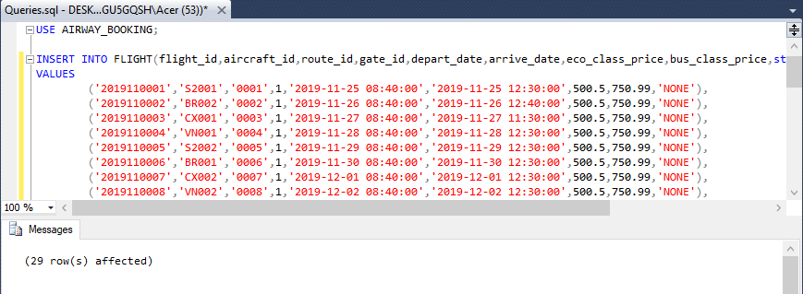

1. Insert data to PASSENGER_INFO.

|  |
| --- |
| USE AIRWAY_BOOKING;  INSERT INTO PASSENGER_INFO(passport_number,name,phone,date_of_birth,address,email)  VALUES ('CSD220601','THOMAS DANIEL','4335337777','1990-05-20', 'US', 'THOMAS@GMAIL.COM'),  ('CSD230601','JOHN DANIEL','5235337777','1990-05-20','CANADA','JOHN@GMAIL.COM'),  ('CSD320602','THORN BROWN','2235337777','1990-05-20','US','THORN@GMAIL.COM'),  ('CSD320891','THUY LINH NGUYEN','4335338777','1990-05-20','VIETNAM','THUYLINH@GMAIL.COM'),  ('CSD550601','SHAWN DANIEL','4995337777','1990-05-20','JAMAICA','SHAWN@GMAIL.COM'),  ('CSD320601','MOHAMED ABI','5335337777','1990-05-20','ARAB','ABI@GMAIL.COM'),  ('CSD260601','SANSAN KAUR','7335337777','1990-05-20','INDIA','SANSAN@GMAIL.COM'),  ('CSD560601','TIN TIN','8835337777','1990-05-20','US','TIN@GMAIL.COM'),  ('CSD228601','THOMSON RAIN','1335337777','1990-05-20','CANADA','THOMSON@GMAIL.COM'),  ('CSD323331','THUNDER RAIN','1335338887','1990-05-20','CANADA','THUNDER@GMAIL.COM'); |

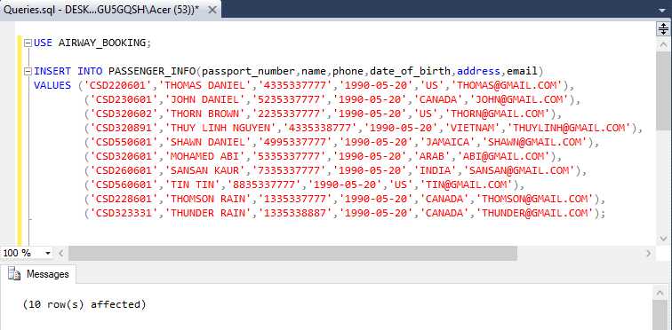

1. Insert data to PASSENGER.

|  |
| --- |
| USE AIRWAY_BOOKING;  INSERT INTO PASSENGER(passenger_id,passport_number)  VALUES ('000001','CSD220601'),('000002','CSD230601'),('000003','CSD320602'),  ('000004','CSD320891'),('000005','CSD550601'), ('000006','CSD320601'),  ('000007','CSD260601'),('000008','CSD560601'),('000009','CSD228601'),  ('000010','CSD323331'); |

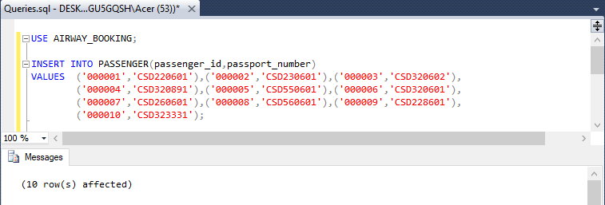

1. Insert to data to PAYMENT_ACCOUNT.

|  |
| --- |
| USE AIRWAY_BOOKING;  INSERT INTO PAYMENT_ACCOUNT(card_id,name,password,expire_date)  VALUES ('3333333333','THOMAS DANIEL',388,'2025-03-01'),  ('1111111111','JOHN DANIEL',308,'2025-03-01'),  ('2222222222','THORN BROWN',380,'2025-03-01'),  ('4444444444','THUY LINH NGUYEN',378,'2025-03-01'),  ('5555555555','SHAWN DANIEL',318,'2025-03-01'),  ('6666666666','MOHAMED ABI',328,'2025-03-01'),  ('7777777777','SANSAN KAUR',378,'2025-03-01'),  ('8888888888','TIN TIN',398,'2025-03-01'),  ('9999999999','THOMSON RAIN',408,'2025-03-01'),  ('1111122222','THUNDER RAIN',580,'2025-03-01'); |

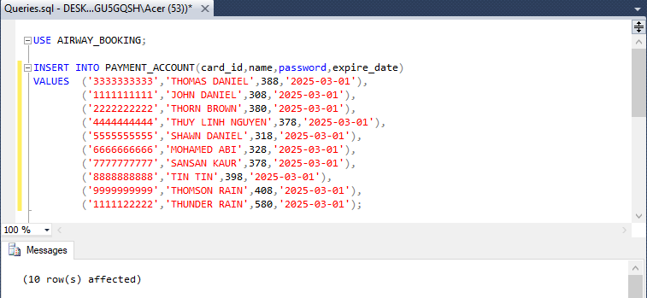

1. Insert data to BOOKING.

|  |
| --- |
| USE AIRWAY_BOOKING;  INSERT INTO BOOKING(booking_id,card_id,status,issued_date)  VALUES('BOOKING00001','3333333333','SUCCEEDED','2019-11-01 08:34:15'),  ('BOOKING00002','1111111111','SUCCEEDED','2019-11-11 08:34:15'),  ('BOOKING00003','2222222222','SUCCEEDED','2019-11-01 08:34:15'),  ('BOOKING00004','4444444444','SUCCEEDED','2019-11-15 08:34:15'),  ('BOOKING00005','5555555555','SUCCEEDED','2019-11-05 08:34:15'),  ('BOOKING00006','6666666666','SUCCEEDED','2019-11-01 08:34:15'),  ('BOOKING00007','7777777777','SUCCEEDED','2019-11-20 08:34:15'),  ('BOOKING00008','8888888888','SUCCEEDED','2019-11-01 08:34:15'),  ('BOOKING00009','9999999999','SUCCEEDED','2019-11-01 08:34:15'),  ('BOOKING00010','1111122222','SUCCEEDED','2019-11-01 08:34:15'); |

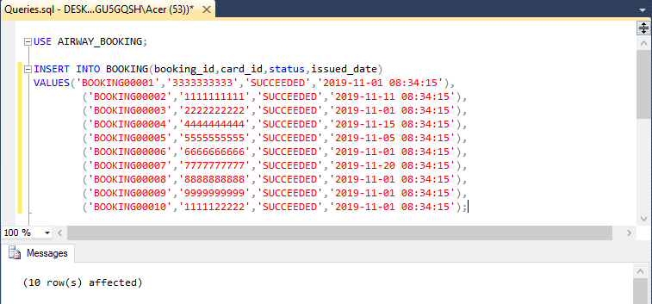

1. Insert data to TICKET.

|  |
| --- |
| INSERT INTO TICKET(ticket_id,booking_id,passenger_id,flight_id,class,seat_number,status,issued_date)  VALUES ('T00001','BOOKING00001','000001','2019110001','ECO','23E','ISSUED','2019-11-22 09:34:15'),  ('T00002','BOOKING00002','000002','2019110002','ECO','11E','ISSUED','2019-11-22 09:34:15'),  ('T00003','BOOKING00003','000003','2019110003','ECO','12E','ISSUED','2019-11-22 09:34:15'),  ('T00004','BOOKING00004','000004','2019110004','ECO','13E','ISSUED','2019-11-22 09:34:15'),  ('T00005','BOOKING00005','000005','2019110005','ECO','14E','ISSUED','2019-11-22 09:34:15'),  ('T00006','BOOKING00006','000006','2019110006','ECO','15E','ISSUED','2019-11-22 09:34:15'),  ('T00007','BOOKING00007','000007','2019110007','ECO','16E','ISSUED','2019-11-22 09:34:15'),  ('T00008','BOOKING00008','000008','2019110008','ECO','17E','ISSUED','2019-11-22 09:34:15'),  ('T00009','BOOKING00009','000009','2019110009','ECO','18E','ISSUED','2019-11-22 09:34:15'),  ('T00010','BOOKING00010','000010','2019110010','ECO','19E','ISSUED','2019-11-22 09:34:15'),  ('T00011','BOOKING00010','000008','2019110010','ECO','19D','ISSUED','2019-11-22 09:34:15'); |

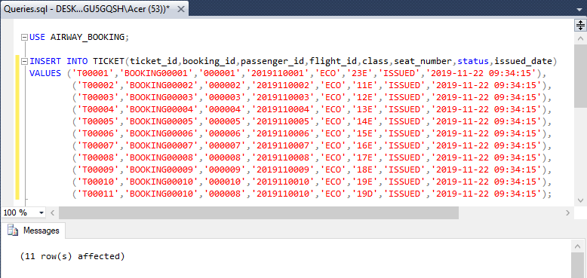

# Constraints Testing

1. Testing of NULL constraint.

|  |
| --- |
| USE AIRWAY_BOOKING;  INSERT INTO AIRLINE(airline_id,airline_name) VALUES(NULL,'AIR INDIA'); |

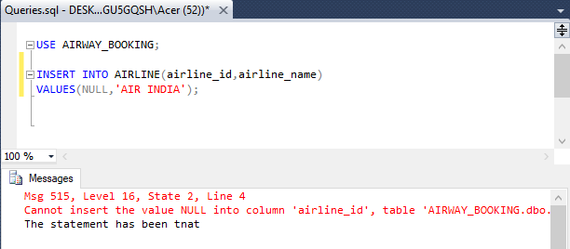

1. Testing of PRIMARY KEY constraint.

|  |
| --- |
| USE AIRWAY_BOOKING;  INSERT INTO AIRPORT(airport_id,name,country,city)  VALUES ('DEL','INDIRA GANDHI INTERNATIONAL AIRPORT','INDIA','DELHI NCR'); |

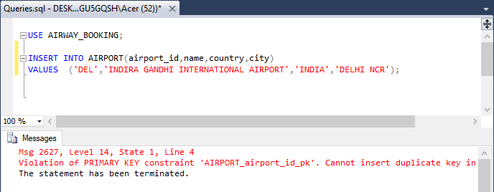

1. Testing of UNIQUE constraint.

|  |
| --- |
| USE AIRWAY_BOOKING;  INSERT INTO PASSENGER_INFO(passport_number,name,phone,date_of_birth,address,email)  VALUES ('R760341','ABI SINGH','7865431201','1987-07-10','INDIA','ABI@GMAIL.COM'); |

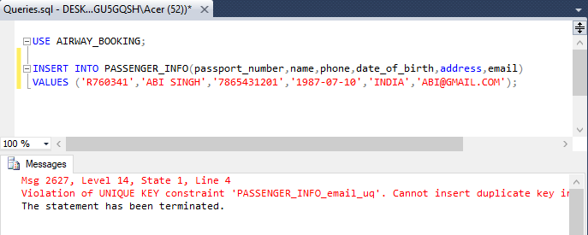

1. Testing of CHECK constraint.

|  |
| --- |
| USE AIRWAY_BOOKING;  INSERT INTO PAYMENT_ACCOUNT(card_id,name,password,expire_date)  VALUES('3333322211','DANISON B',607,'2019-12-11'); |

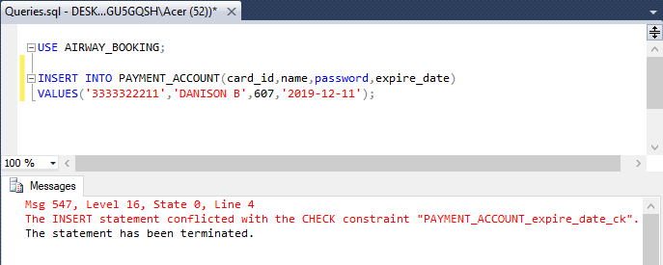

1. Testing of FOREIGN KEY.

|  |
| --- |
| USE AIRWAY_BOOKING;  INSERT INTO TERMINAL(terminal_id,airport_id,terminal_name) VALUES (21,'HBP','T'); |

